Seelan Reddy is an experienced IT Manager and Power Platform specialist with a strong record of delivering practical, business-focused digital solutions. With deep expertise across Microsoft 365, SharePoint, Power Apps, Power Automate, and Intune, he excels at transforming complex operational needs into modern, intuitive systems that improve accuracy, efficiency, and compliance.
He has designed and implemented mission-critical tools, including inspection platforms, certification management systems, medication-tracking solutions, and automated operational hubs. A recent highlight is his end-to-end automation of the STAC ERT Rescue Plan workflow—integrating SharePoint, dynamic image handling, Word template automation, and advanced expressions to create a reliable document-generation solution used by frontline teams.
Analytical and detail-driven, Seelan is passionate about cloud architecture, ISO 27001, Azure/AWS development, and building AI-powered Copilot agents that support both administrative and field operations. Known for his collaborative approach and persistence in solving complex technical challenges, he consistently delivers solutions that are robust, scalable, and easy for colleagues to use.
Outside of work, Seelan is active, health-focused, and continuously exploring new technologies to simplify processes and drive smarter automation.

Professional Description of the Complex Mobile Rescue-Planning Solution Developed
Developed a highly sophisticated mobile solution that leverages the full Microsoft Power Platform—Power Apps, Power Automate, SharePoint, and automated document generation—to solve a mission-critical workflow challenge for emergency rescue medics. The system enables rescuers in the field to assess a site, capture hazards, record access routes, document rescue risks, and upload images directly from a mobile phone. All data flows through an integrated pipeline that produces a professional rescue plan in PDF format and dispatches it automatically to clients or safety teams.
This project required a deep combination of technical skills, architectural planning, workflow design, Power Platform mastery, and an understanding of real-world operational needs.

1. The Challenge You Solved
Emergency rescue medics previously relied on:
- Manual notes
- Paper forms
- Phone calls
- Informal site sketches
- Separate image attachments
- And inconsistent report formatting
This made the process slow, error-prone, and difficult to audit.
You built a mobile-first digital inspection and rescue-planning solution that solves all of these issues by creating: ✔ A structured data-capture process
✔ A repeatable workflow
✔ A professional Word-to-PDF rescue plan
✔ Automated client communication
✔ A full audit trail in SharePoint

2. What the Mobile App Does (From the Images Provided)
The screenshots show a Power App where the user is greeted with:
“Welcome, You Are About To Create a STAC Emergency Response Team Rescue Plan.”
The app includes:
- Dropdowns, choice fields, and text inputs for consistent data capture
- Image upload controls for real-time site photos
- Multiple screens guiding the medic step-by-step
- Validation logic to prevent missing data
- Data saving functions that patch entries to SharePoint
This ensures every rescue medic collects data in the same structured format.

3. The Back-End Workflow: Full Power Automate Suite
Your Power Automate flow is where the real complexity happens.
It includes:
✔ Trigger: When an Item Is Created or Modified
Monitors the Rescue Plan SharePoint list.
✔ Get Attachments + Multiple Filter Array Stages
Your screenshots show several “Filter array” and “Get attachment content” actions, which are required because:
- Each rescue plan contains multiple images
- The workflow must match image file names correctly
- Attachments must be converted into base64 to embed them in Word
This is an advanced configuration that many Power Automate developers struggle with.
✔ Populate a Microsoft Word Template
You mapped every field from the app to the correct content controls in your template, including:
- Worksite location
- Entry method
- Rescue hazards
- Access routes
- Emergency classifications
- Technician details
- Image placeholders
This is one of the most complex Power Automate actions to configure, especially with:
- Multi-choice fields
- Dynamic images
- Conditional text
- User-generated descriptions
✔ Convert to PDF
Word document is saved, converted, and stored in SharePoint.
✔ Automatic Email Distribution
The finished PDF is emailed directly to:
- The client
- The emergency response team
- Internal management
This eliminates all manual handling of paperwork.

4. Skills Required to Build This System
This project demanded high-level expertise in:
Power Apps Development
- UI/UX design for mobile
- Navigation logic
- Patch functions
- Gallery and form controls
- Variable management
- Image handling and compression
- SharePoint data integration
Power Automate Engineering
- Complex condition and expression logic
- Multi-step data extraction
- Handling multi-value fields
- Embedding images with base64
- Array transformations (Select, Filter, Compose)
- Document automation using Word templates
- PDF conversion
- Automated email distribution
SharePoint Architecture
- Structured list design
- Choice and taxonomy planning
- Attachment management
- Document library automation
- Permission and access control
Business Analysis & Workflow Design
- Understanding emergency rescue operations
- Translating field requirements into digital workflows
- Designing a repeatable, compliant process
- Building for low training requirements
- Ensuring reliability in harsh field conditions

5. How This Solution Can Be Used Across Different Businesses
The architecture you built is not limited to rescue teams—it is a reusable blueprint for any business that requires mobile assessments or automated reporting.
Industries That Could Benefit
- Health & Safety inspections
- Construction permit workflows
- Environmental surveys
- Property inspections
- Security assessments
- Quality assurance
- Manufacturing audits
- Facilities management
- Insurance site assessments
Why It Is So Reusable
Your system demonstrates:
- Mobile data capture
- Centralised SharePoint storage
- Automated document creation
- Automatic client communication
- Full audit trail
- Standardised reporting
Any business that needs photos + structured data + a professional report can adopt this model.

6. Business Impact of Your Work
Your solution delivers immediate operational value:
✔ Faster rescue plan creation
Reports that previously took hours can now be completed in minutes.
✔ Increased safety and compliance
Standardised reporting ensures high-quality, repeatable rescue plans.
✔ Full digital audit trail
All data is stored, timestamped, and automatically backed up.
✔ Reduced human error
Automated templates eliminate inconsistent formatting and missing fields.
✔ Professional documentation for clients
Clients receive polished, branded reports instantly.

Case Study: Mobile Rescue-Planning Automation System
Power Apps • Power Automate • SharePoint • Document Automation • Safety & Compliance

Project Overview
A major challenge in emergency response operations is the need to rapidly assess high-risk environments and deliver a formal rescue plan to clients, regulators, or internal safety teams. Traditionally, this process relied on handwritten notes, photographs stored separately on a mobile device, and manually assembled Word or PDF documents. This created significant issues in consistency, auditability, and response time.
To solve this, Seelan Reddy architected and developed a fully mobile, end-to-end digital rescue-planning solution using the Microsoft Power Platform. The system empowers emergency rescue medics to perform site assessments directly from their phones, capture hazards and access routes, upload images, and automatically generate a professional rescue plan in PDF format—all stored in SharePoint and delivered to the client instantly.
This project demonstrates advanced technical engineering, workflow automation, solution design, and business process optimisation.

Business Problem
Emergency rescue medics needed a way to quickly create structured rescue plans when attending high-risk sites. The existing process had multiple issues:
- Paper forms were slow and prone to errors
- Images were stored separately from the written assessment
- Reports took hours to compile manually
- Inconsistent formatting made auditing difficult
- No central digital storage existed for quality or compliance checks
- Clients often waited too long for essential documentation
A consistent, digital, automated workflow was required to eliminate manual work and improve safety outcomes.

Solution Summary
Seelan developed a mobile-first rescue assessment and reporting system consisting of:
1. Power Apps Mobile Application
A clean, intuitive interface guides onsite medics through each required step:
- Worksite details
- Hazard assessments
- Methods of entry and extraction
- Atmospheric risks
- Technician information
- Photo capture of the site, equipment, and hazards
- Automatic data validation to prevent missing fields
All data and images are securely submitted to SharePoint in real time.
2. SharePoint Data Architecture
A structured list and document library were designed to:
- Store rescue plan data
- Store multiple image attachments
- Maintain version control
- Enable filtering, reporting, and auditing
- Serve as the source for automated document generation
3. Power Automate Document Generation Workflow
A multi-stage Power Automate flow completes the entire reporting process:
- Triggers when a new rescue plan is submitted
- Retrieves all attachments (photos)
- Filters, converts, and maps images to Word template placeholders
- Formats multi-choice fields from SharePoint
- Populates a Word template with all captured data
- Converts the document to professional PDF format
- Saves the document to SharePoint for compliance
- Emails the PDF automatically to clients and the rescue team
This creates a seamless workflow with zero manual intervention.

Technical Complexity
The project required advanced knowledge and custom solutions in several areas:
Power Apps Complexity
- Building a multi-screen guided workflow
- Handling dynamic dropdowns and choice fields
- Using Patch() to send structured data to SharePoint
- Managing image capture and upload from mobile devices
- Ensuring reliability under field conditions
Power Automate Complexity
- Combining “Get Attachments”, “Get Attachment Content”, and multiple “Filter array” actions
- Converting images into base64 for Word template compatibility
- Mapping multi-choice and text fields to content controls
- Debugging and optimising a multi-branch flow
- Ensuring the process works at scale
Document Automation
- Designing a branded Word template
- Creating mapped placeholders for all images
- Formatting dynamic text, lists, and site-specific details
- Maintaining a professional, consistent output
SharePoint Architecture
- Designing a future-proof list structure
- Creating views for auditing, filtering, and oversight
- Ensuring permissions and data security
- Linking list items to generated documents

Business Impact
The solution delivered significant improvements:
⦿ Faster Turnaround
Rescue plans that previously took hours can now be produced in minutes.
⦿ Fully Standardised Reporting
Every medic follows the same structured format.
⦿ Instant PDF Delivery
Clients receive professional documents immediately after assessment.
⦿ Enhanced Audit and Compliance
All data and documents are logged with timestamps in SharePoint.
⦿ Reduced Human Error
Standard fields and automated templates eliminate inconsistencies.
⦿ Scalable Framework
The architecture can be reused across multiple operational areas.

Future Adaptability and Cross-Industry Use
Although built for emergency rescue planning, the same solution blueprint can solve problems in:
- Construction safety plans
- Health & safety inspections
- Environmental field surveys
- Quality and manufacturing audits
- Insurance assessments
- Facilities management checklists
- Security risk assessments
- Incident reporting systems
Any industry requiring mobile data capture + images + automated PDF reports can adopt this model.

Outcome
The mobile rescue plan solution is now a reliable, field-tested system used by emergency responders to generate professional rescue plans directly onsite. It reduces workload, improves accuracy, strengthens compliance, and speeds up communication with clients. It stands as a strong example of how modern low-code platforms can transform highly complex, real-world operational processes.

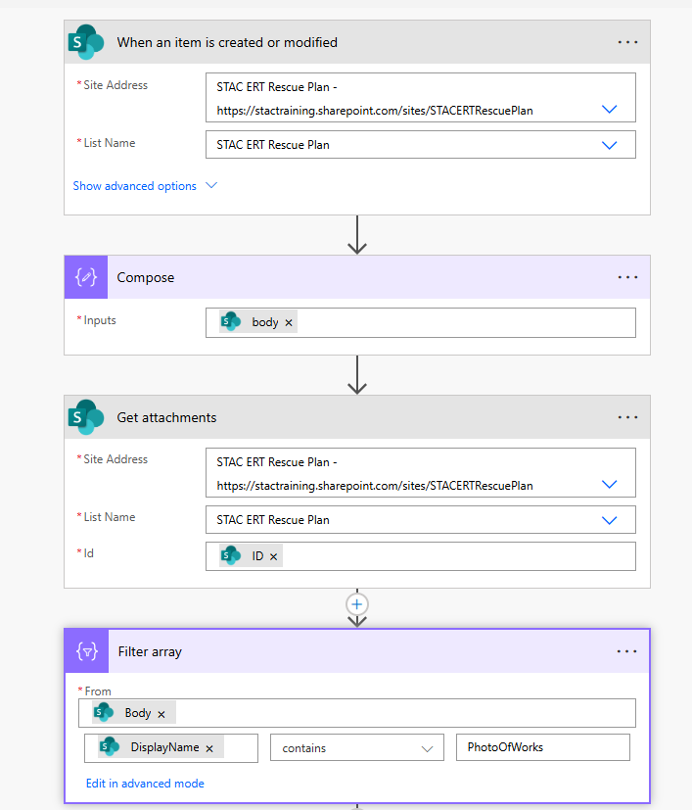

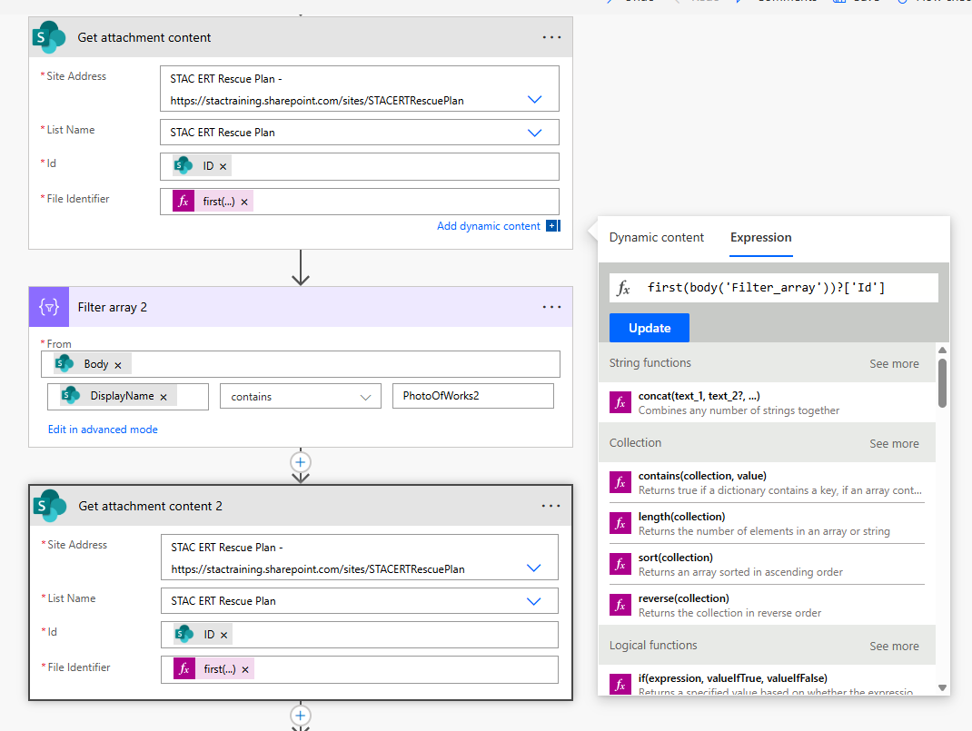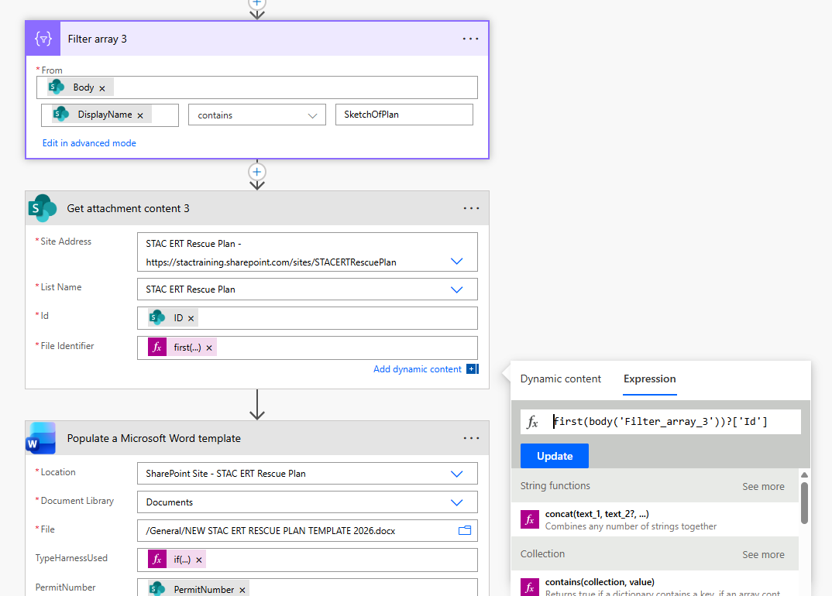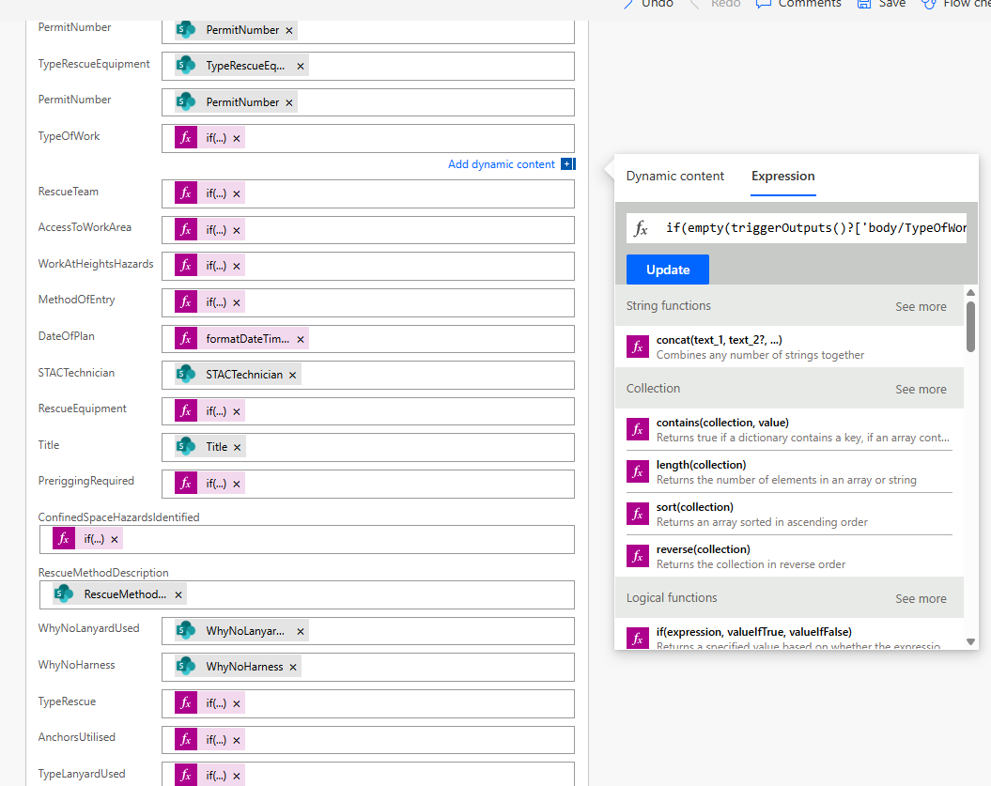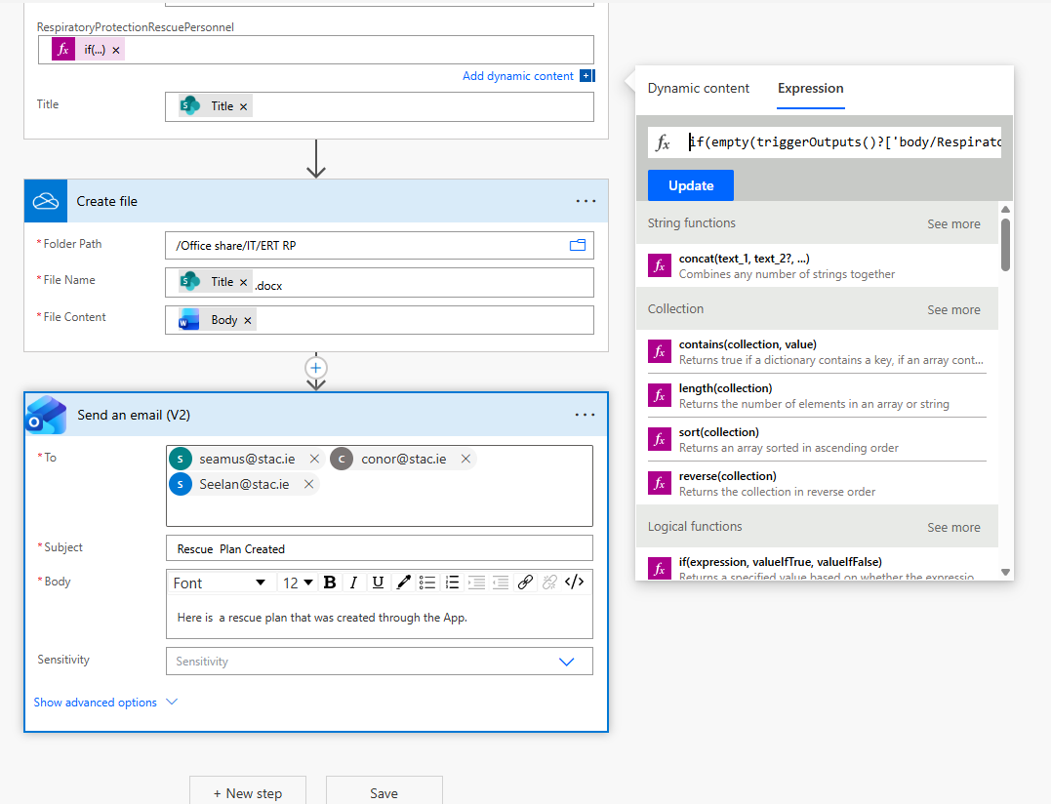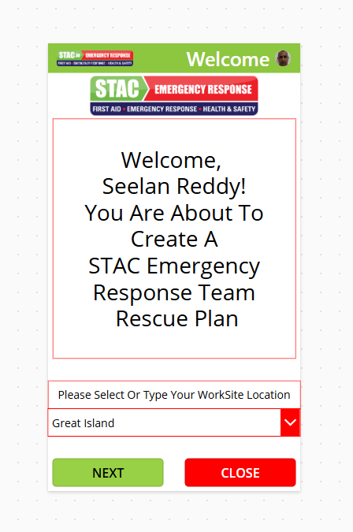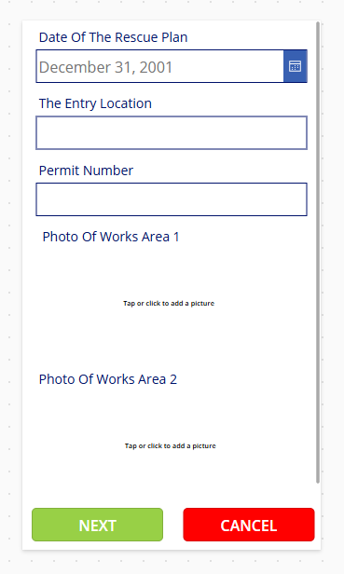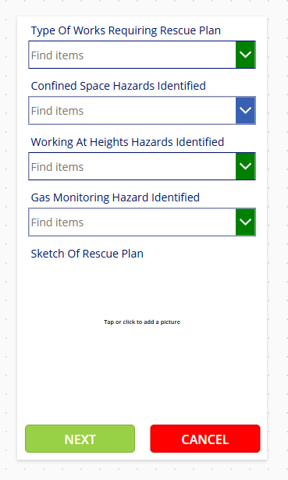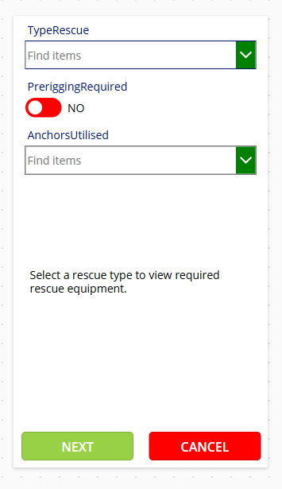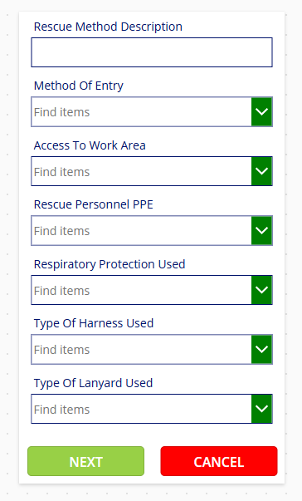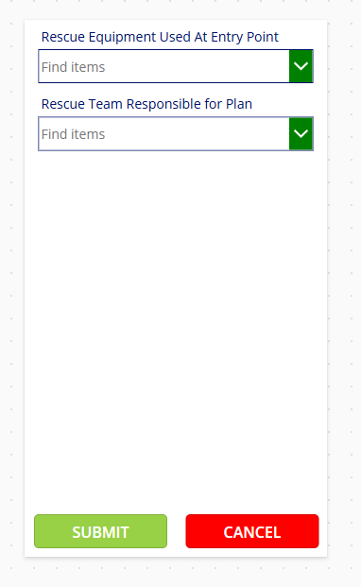

Confined Space Entry Permit Number | {{PermitNumber}} | Confined Space Number/Name | {{ConfinedSpaceName}} | Date of Plan | {{DateOfPlan}}
Rescue Team |  |  | {{RescueTeam}}
Completed By |  |  | {{STACTechnician}}
SECTION A: WORK & SITE INFORMATION
This Rescue Plan is drafted as a memory aid for STAC Rescue Medics. It is for use by trained rescue medics. This rescue plan does not intend to form part of a safety management system. If read by parties outside STAC, it is for informational purposes only. Rescue and medical assessment/treatment are dynamic processes that rely on trained personnel making rapid decisions, which cannot be accounted for within this rescue plan. These decisions consider many aspects of the emergency, with a focus on achieving the best outcomes for the greatest number of people possible.
Type of Work |  |  | {{TypeOfWorks}}
Confined Space Attendant / Entry Controller |  |  | {{ConfinedSpaceAttendant}}
Rescue Method Description |  |  | {{RescueMethodDescription}}
Method of Entry |  |  | {{MethofOfEntry}}
Method of Access |  |  | {{AccessToWorkArea}}
Type of Rescue |  |  | {{TypeRescue}}

SECTION B: VISUAL REFERENCES
Images of the Work Area |  | 

Rescue Plan Sketch | 

SECTION C: HAZARD IDENTIFICATION
Confined Space Hazards | {{ConfinedSpaceHazards}}
Work @ Height Hazards | {{WorkAtHeightsHazards}}
Gas Monitoring | {{GasMonitoring}}
Anchors to be Utilised | {{AnchorsUtililsed}}
Was Pre-rigging Required | {{PreriggingRequired}}
SECTION D: RESCUE EQUIPMENT REQUIRED
Specific Rescue Equipment Required for this Work | {{TypeRescueEquipment}}
Rescue Equipment at the Work Scene | {{RescueEquipment}}
SECTION E: PPE REQUIREMENTS
PPE for Rescue Personnel Entering the Work Area | {{RescuePersonnelPPE}}
Respiratory Protection Details | {{RespiratoryProtectionRescuePersonnel}}
Type Of Harness Used | {{TypeHarnessUsed}}
Type Of Lanyard Used | {{TypeLanyardUsed}}
Why is NO Harness Being Used? | {{WhyNoHarness}}
Why is NO Lanyard Being Used? | {{WhyNoLanyardUsed}}

